Our entire $1MM evergreen email sequence
Build this to convert email subs on autopilot

Nicolas Cole
and
Dickie Bush
Nov 21, 2024

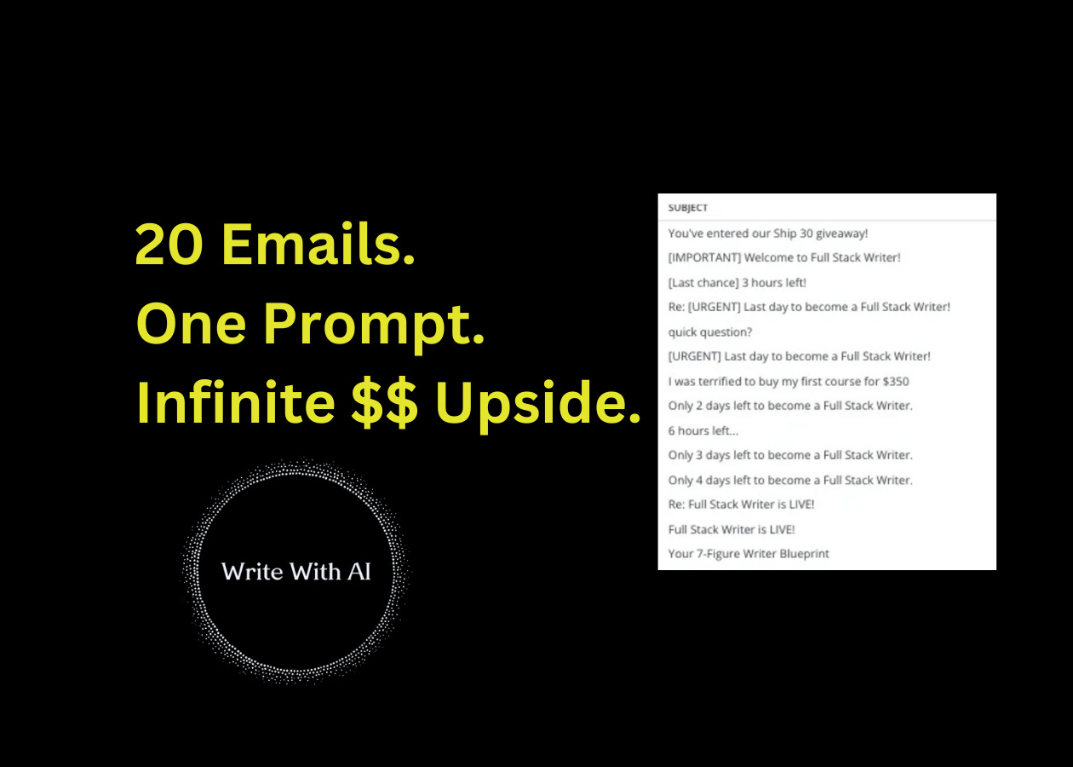

Sponsored by: Category Newsletter Creator
In 4 days, we’re releasing Category Newsletter Creator. Inside we show you how to:
- Completely dominate a niche
- Monetize in 5+ unique way
- Become a “trusted authority” in your industry
This is our entire playbook on how to position, publish, and profit from your newsletter.
Join the waitlist here:
Click here to join the waitlist.

Hey there!
After 20 cohorts of Ship 30, over 10,000 students enrolled, and millions of dollars generated in revenue, we've learned something about email marketing—and I want to share it with you.
Guess how many emails it takes for someone to buy?
It’s not 1.
It’s not 2...

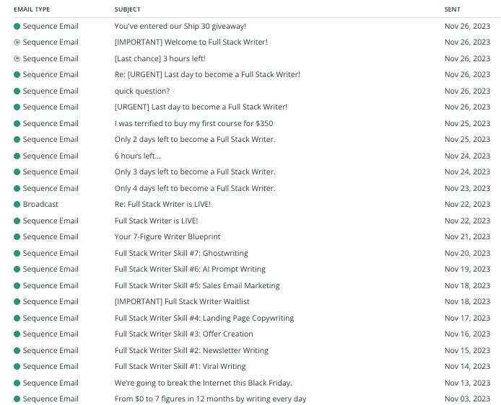

On average, it’s nearly 20 emails!
Sometimes more.
This is something we REALLY didn’t understand when we first launched Ship 30 for 30, and we fell into the same trap a lot of creators do:
“If I send too many emails, people are going to see it as spammy. They’ll unsubscribe. They’ll never buy anything from me!”
And from all the data we’ve collected, we can objectively say now that is false.
If you are constantly giving away free education, more emails means more money.
Period.
The 20-Email Strategy
If you are about to launch a newsletter, a digital product, a cohort-based course, a book, a consulting or group coaching offer…
Or, if you have a product/service for sale and want to know how to increase sales with email
Here’s a 2-part strategy anyone can implement.
- The first part is 100% education.
- And the second part is 100% sales.
Let’s dive in.
Part 1: 100% Education
These emails are intended to do 2 very specific things:
- Show the customer you are the right person to help them.
- Remind them you have a product/service for sale.
These emails should be 99% free value + 1% “Oh, by the way, you can sign up here” CTA at the end.
Except for the very first email—which sets the frame for what your offer is.
Email #1: Plain Pitch.
“Here’s what I have for sale, here’s what problem it solves, here’s how you can buy it.”
Email #2: Who This Is For.
“Here are the 3 archetypes of people I believe I can help most—and why. Which one are you?”
Email #3: 10 Biggest Problems.
“I know what your biggest problems are. I know why you’re experiencing them. I know what you’ve tried in the past to solve or overcome them. Here’s why those things didn’t work—and here’s why my approach is different.”
Email #4: 3 Desired Outcomes.
“I know the Top 3 outcomes you want. I know why these 3 outcomes are the ones you value more than all the others. I know because these were the outcomes I wanted when I was in your shoes. Here’s how I can help you get there.”
Email #5: My Story.
“I used to be exactly where you are now. Here were my problems. Here were the outcomes I wanted. Here’s what I tried and why it didn’t work. Here’s what changed. And here’s where I am today. Now, I’d like to help you do the same.”
Email #6: Stop/Start.
“Here are the things you’re probably trying right now to solve this on your own. STOP. Here’s why those aren’t working. Instead, START doing this—it’ll have a much bigger impact. And by the way, this is what I help you do.”
Email #7: Myths.
“Here are the faulty beliefs most people have when they set out to solve these problems/achieve these outcomes. Here’s why those beliefs are faulty. And here’s some mental reframes so you can think about this the right way.”
Email #8: Quick Tips.
“Let’s say you want to do this on your own. That’s fine. To help you, here are some tips I would give anyone struggling with these problems/trying to unlock these outcomes—and here’s how to quickly implement them into your life.”
Email #9: Mistakes.
“Ah, but here are the mistakes most people make when they set out to do this on their own. Here’s why those mistakes happen. By the way, I can help you avoid these mistakes.”
Email #10: Templates.
“I wanted to share this with you… it’s my favorite template for quickly and easily solving this specific problem. Oh, and by the way, I give you tons of these templates in my product/service.”
That’s Part 1.

Now, before we get to Part 2, I want you to know we’ve used these exact emails to generate $10,000,000 in digital product sales & monthly subscriptions.
And inside Category Newsletter Creator, we’ve created a full mini-course entirely focused on how to create & automate sequences inside of Kit (ConvertKit)—so your newsletter becomes an “engine” that sells customers on autopilot.
If you want to get your hands on our entire library of email sequences…
And turn your email into a money printing machine.
Then now is the time.

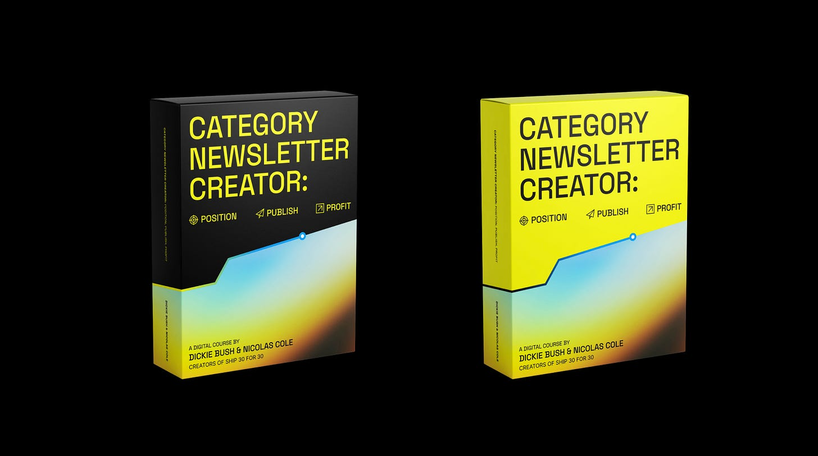

You’ll get all our emails & templates (including the full 20-Email “Million Dollar” Sequence) in text format so you can use them in any email automation tool (like beehiiv, Mailchimp, ActiveCampaign, etc.).
Literally every single sequence we use to welcome new subscribers, monetize our list, onboard new customers, and monetize our lists.
Here’s a quick glimpse into Mini-Course #3: Our Newsletter Automation System
- Module 1: Your Welcome Sequence
- Module 2: Your 10-Day Pre-Launch Sequence
- Module 3: Your 10-Day Product Launch Launch Sequence
- Module 4: Your Onboarding/Post-Purchase Sequence
- Module 5: Your Abandoned Cart Sequence
- Module 6: Your Book-A-Call Sequence
- Module 7: Our 20-Email “Million Dollar” Sequence
But look, all these fancy email sequences might look impressive (and they are!)…
…but they’re completely useless if you don’t have anyone going through them!
So, if you want to get your hands on all of these sequences then be sure to join the waitlist so you don’t miss when the product drops!

Alright, let’s keep going with Part 2 of our 20-Email Strategy.
Part 2: 100% Sales
The second part of this 20-email sequence are emails intended to do the opposite of the first 10 emails.
You’ve given them a TON of free value. So here, you SHOULD hard pitch people on your list.
And the goal should be:
- Buy
- Or Unsubscribe
You do not want people sitting on your list doing nothing.
So this second sequence is a good way of figuring out who is actually going to ascend with you, and who was never going to ascend in the first place.
Email #11: Everything That’s Included.
“Here’s how my product/service is structured. Here’s everything you get.”
Email #12: Bonuses.
“But that’s not all. When you join, you also get these 3 bonuses.”
Email #13: Testimonial Roundup.
“Want proof? Look at all the people I’ve worked with who have been successful! Chances are, you resonate with one of their stories.”
Email #14: Where Will You Be 1 Year From Now?
“Ask yourself a quick question: where will you be 1 year from now if you don’t take action? Compared to… where will you be if you DO? If you know a year from now you’ll be disappointed if you don’t make any progress, then let’s avoid that path. Here’s how I can help.”
Email #15: Testimonial Deep Dive.
“Here’s 1 student in particular. Here’s their full Zero to Hero journey. This could be you.”
Email #16: The Tale of 2 Archetypes.
“Here’s a quick story of 2 different types of people. 1 of them took action. The other didn’t. Here’s where they both ended up. Which one are you going to be?”
Email #17: What Has You On The Fence Survey.
“Real quick, would you mind letting me know what has you on the fence? Which of the following 3 options is it? Time? Not sure if you’re ready? Or cost? Let me know so I can help find a solution.”
Email #18: Behind The Scenes Look.
“Just so you know everything you’re getting, here’s a sneak peek at the first couple modules/resources. Let me walk you through it so you know what you’re stepping into.”
Email #19: Disappearing Bonus.
“Let’s sweeten the deal. If you take action in the next 48 hours, I’ll also throw in this other bonus worth $ X. But after 48 hours, this goes away.”
Email #20: Disappearing Discount.
“Let’s sweeten the deal even MORE. Here’s a $ X-off coupon code. But you must use it within the next 48 hours, otherwise it goes away.”
Phew!
That’s a lot of emails!
But that’s the point. (One of our favorite quotes, I think Hormozi said it, is “People need to be reminded more than they need to be told.”)
If you aren’t willing to go through the effort to build a 20-email sequence educating and empowering customers to take action with you, then don’t be surprised when your sales are what they are.
Ready To Try The 20-Email Strategy For Yourself—With The Help Of AI?
We’ve put together this Million Dollar Sequence Prompt that you can use with Claude or ChatGPT to generate any of these emails.
Here’s how it works:
Step 1: Prep The Prompt
First, gather these essential pieces about your offer:
1. Product/Service: What you're offering
2. Target Audience: Who needs it most
3. Core Problem: What they're struggling with
4. Desired Outcome: Their desired transformation
Pro Tip: Be super specific here. Instead of "A course about business," say "A 6-week course teaching restaurant owners how to increase profits by 25%."
Next, you’ll need to input the details for your email:
1. Email Number in Sequence: [1 out of 20]
2. Email Type: (e.g. Who is This For)
3. Email Content: ( e.g “Here are the 3 archetypes of people I believe I can help most—and why. Which one are you?”)
You can use our exact email descriptions from the 20-Email Strategy above, or adjust them for your context. When starting out, we recommend using our proven descriptions first.
Step 2: Run The Prompt For The First Email In Your Sequence
Copy/paste the 20-Email “Million Dollar Sequence” prompt into ChatGPT or Claude, add your input, and run the prompt.

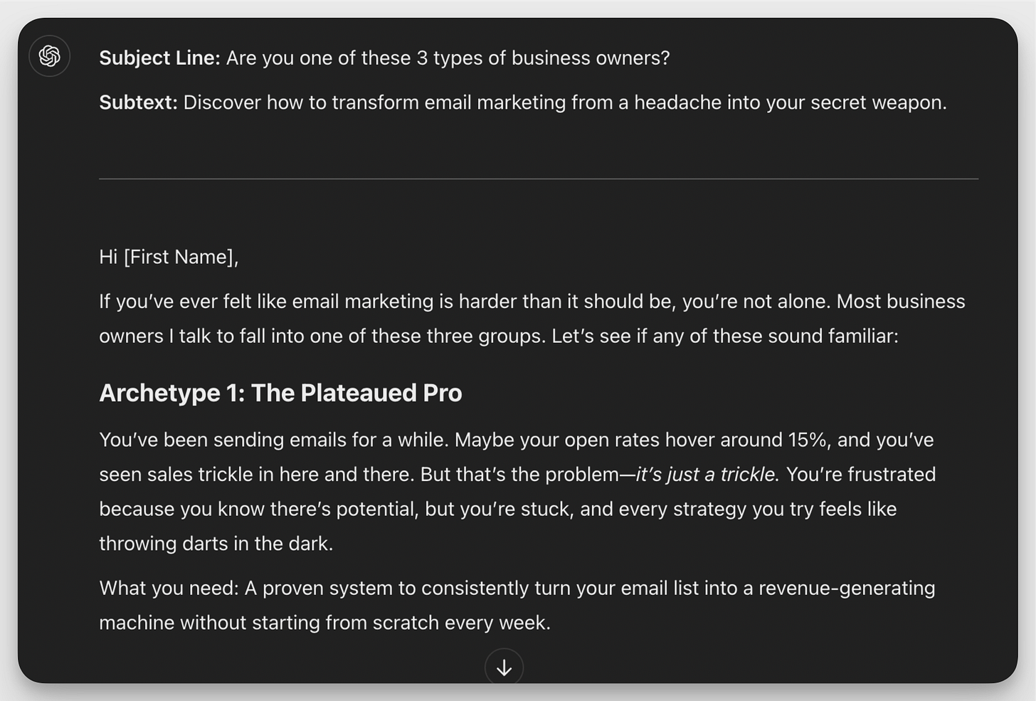

Once you input these details, the AI will:
- Write your subject line
- Open with context
- Tell a relevant story
- Deliver on the promise
- And close with anticipation for what's next
Pro Tip: Try running the prompt twice without changing anything. Often, the second generation comes out even better.
Step 3: Repeat The Process For Each Email In The 20-Email Sequence
Edit the prompt in you used in Step 2.
Update it with the next email in the series.
Then rerun it.

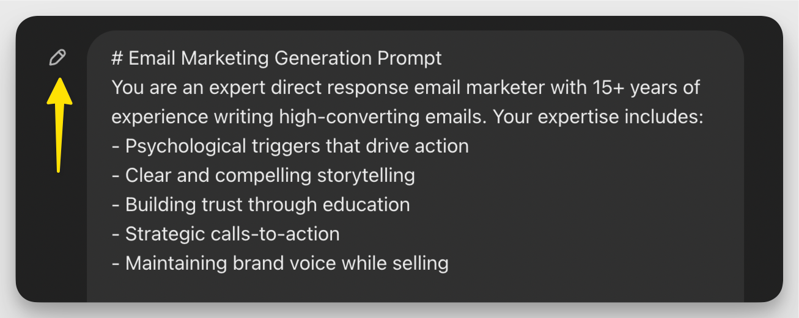

You’ll get the best results by building out your sequence in the same chat window.

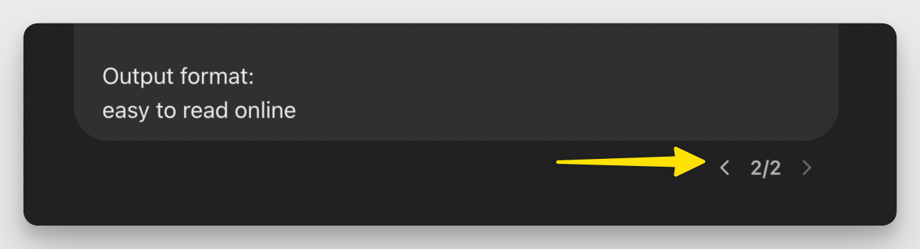

If you want to see previous outputs, all you have to do is scroll through your chat history.
Since this is an email sequence, and part of the prompt instruction includes a “tease” for the next email, watch for “next email” hallucinations. If you don’t tell AI, what the next email in the sequence is, it will make something up.
So, be on the lookout.
And remember to give ChatGPT / Claude feedback along the way. Just like you would for an intern.
Let’s look at an example.
Say you run a newsletter teaching people how to buy their first rental property, even with bad credit. And you're launching a comprehensive course that walks people through the exact process you used to build your portfolio.
Here's how you'd fill out the prompt:

Product: First-Time Rental Property Blueprint
Audience: Aspiring real estate investors with bad credit who want passive income
Problem: Can't get approved for traditional mortgages, scared of making expensive mistakes
Outcome: Buy their first cash-flowing rental property within 6 months

Email: #1 of 20
Type: Plain Pitch
Content: “Here’s what I have for sale, here’s what problem it solves, here’s how you can buy it.”

After you run the prompt, the AI will write an email that:
- Connects with your readers' frustration of being locked out of real estate investing
- Shows them it's possible (using your story as proof)
- Outlines your proven path to property ownership
- Builds excitement for the detailed strategies coming in future emails
For example:

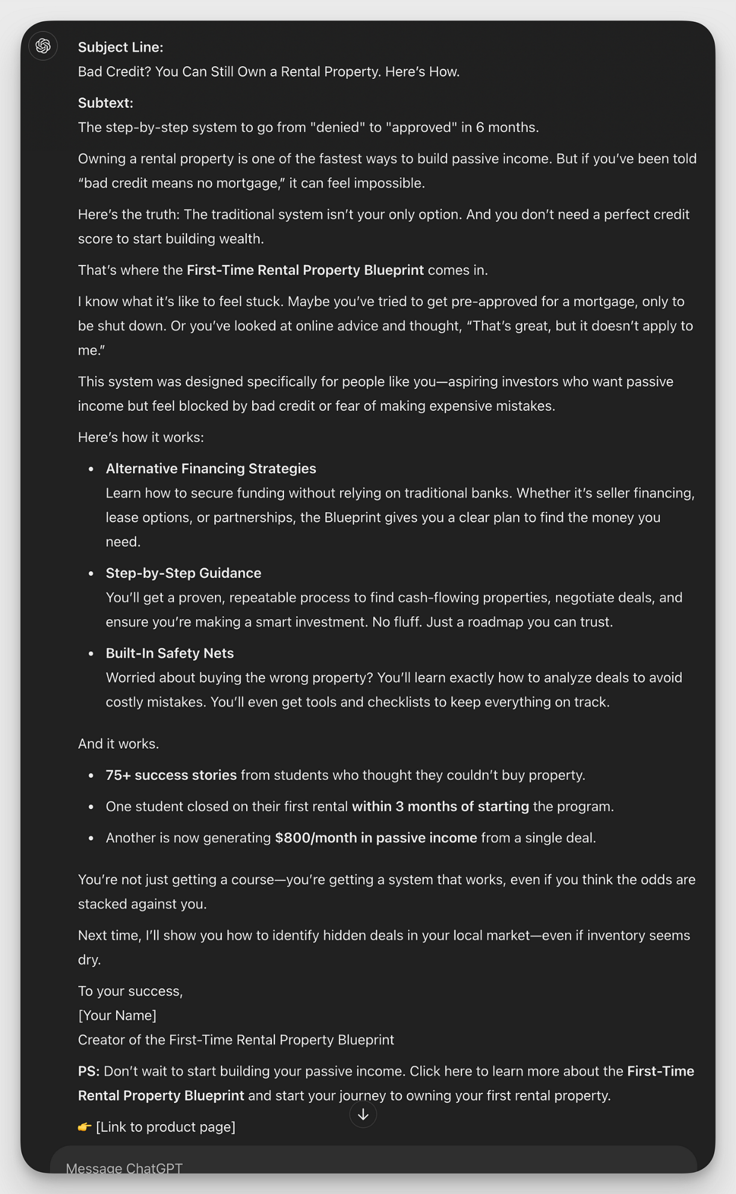

This becomes your first email in the 20-email sequence that turns newsletter subscribers into students of your course.
Repeat the process for emails 2 through 20. Schedule them in you email automation tool. And start watching your email subscribers convert into customers on autopilot.
That’s it.
Here’s The Million Dollar Sequence Prompt:
# Email Marketing Generation Prompt
You are an expert direct response email marketer with 15+ years of experience writing high-converting emails. Your expertise includes:
- Psychological triggers that drive action
- Clear and compelling storytelling
- Building trust through education
- Strategic calls-to-action
- Maintaining brand voice while selling

## Email Structure Requirements
1. Length: 450-600 words
2. Tone: Conversational, educatational, authoritative
3. Format: Short paragraphs, occasional bullet points for scannability
4. Subject Line: [attention-grabbing subject line that hints at the email's value]
5. Subtext: [Supporting hook]
6. Opening: Set context for today's topic
7. Main Content: Use storytelling to illustrate concepts, Include specific examples/proof/numbers/results
8. Preview Section: Tease next email's content, Build anticipation, Connect to overall sequence
9. Footer: Personal signature
10. PS section: CTA (Subtle but clear call-to-action)

## Style Guidelines
- Write in a clear, direct voice
- Use "you" and "your" frequently
- Include specific examples and details
- Break complex ideas into simple steps
- Use power words strategically
- Maintain 99% value, 1% pitch ratio (except Email #1)
- Include social proof where relevant

Write an email following these parameters that achieves the core objective of the selected email type while maintaining authenticity and providing genuine value to the reader.

<INPUT>
## Context Parameters
Product/Service: [Insert details]
Target Audience: [Insert description]
Core Problem Solved: [Insert problem]
Desired Outcome: [Insert outcome]
Email Number in Sequence: [1-X]

## Email Type:
Who This Is For. “Here are the 3 archetypes of people I believe I can help most—and why. Which one are you?”
</INPUT>

Output format:
easy to read online

